HTML ASSIGNMENT

CODE preview and article preview

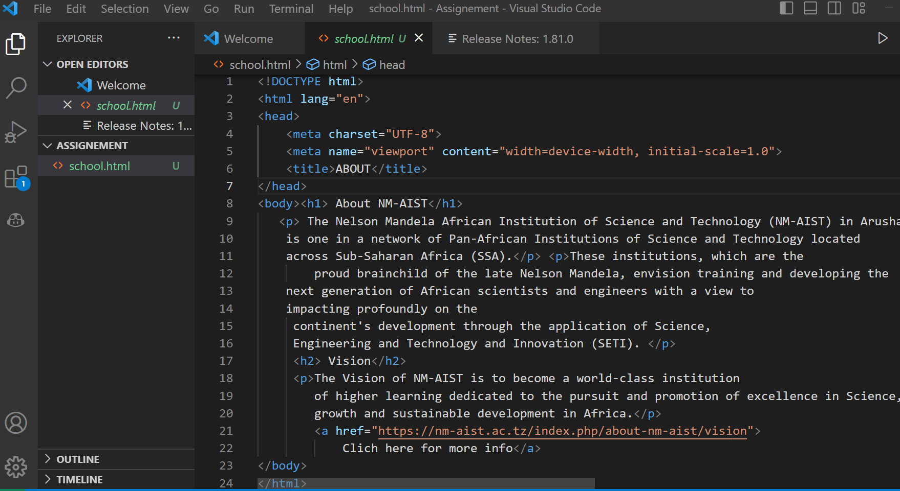

**Article preview**

